Budget Rent a Car
of British Columbia

Voucher + Certificate Design and Constraints

Version 1.00

Note: The information contained in this document is confidential and may not be disclosed to any parties outside of Budget Rent-a-Car of British Columbia Ltd. without written consent by one of its officers.

Copyright (C) 2010 Budget Rent-a-Car of British Columbia Ltd.

Table of Contents

Introduction to Voucher and Certificates

The original procedure for handling rental certificates is by recording the certificate number, issuer and amount in Printed Comments; add the corresponding organization for direct billing purposes and manually split charges for the rental billing items to reach the amount on the certificate. This process in turns messes up the accounting entries when GIS closes the contract and the accounting department will have to adjust them accordingly.

Certificates are considered a form of payment but they themselves are insufficient to check out a contract. Like before, GIS still requires a primary payment of the form of direct bill, credit card or cash/debit card, and the voucher or certificate can be used on top of that primary payment.

Voucher/Certificate Window

Controls
Req*:
Y – always mandatory
N – always optional
S – sometime optional (see Comments for details)
D – display only

Field | Req* | Validation | Comments
Type | Y | Selection only | The two prepayment types on GIS are voucher and certificate.
Collected At | D |  | Defaults to gis.ini location.
Issuer | Y | Selection only | For certificates, GIS does not allow more than one issuer in a contract.  For vouchers, GIS automatically defaults the issuer based on BCD#.
Amount | Y | Positive or negative double | Entering a negative amount is essentially the same as removing a certificate/voucher.
Currency | Y | Selection only  Value controlled by Currency table | Defaults to CDN $.
Exch | D |  | Valued controlled by the Exchange Rate table.
Contract Currency Amt | D |  | Calculated by GIS based on Amount, Currency and Exch.
Voucher/Certificate Number | S | Up to 20 alphanumeric chars. | For certificates, this field is mandatory.  For vouchers, this field is mandatory if the PO_Required field is set for the AR customer code on ACCPAC.

Notes:
- For certificates, GIS allows the switching of issuers as long as the total certificate amount for the first added issuer is zero.
- The Issuer field defaults to the last-used issuer. When the Voucher/Certificate window is accessed for the first time, the Issuer field is empty.
- The total certificate amount for the issuer must be larger or equal to zero in order to exit from the Voucher/Certificate window.
- All certificates and vouchers added through this window are saved in the Prepayment table.
- Any US certificate amount is converted into its Canadian equivalent and stored in the GIS Customer Deposits account (Unlike US Cash, the difference between the US and Canadian amount will not go into the Foreign Exchanges – US GL)

Voucher and Certificate issuers are set up in the armaster_base table through the price_code column. Once the certificate issuers are identified, enter ‘CERT’ in the price_code field for the corresponding customer_code of the AR account that handles rental certificates. Similarly, enter ‘TOUR’ if the AR account involves vouchers. Vouchers and certificates go hand in hand in the Voucher/Certificate window on GIS. This means that both vouchers and certificates must exist in the armaster_base table for them to appear on GIS. If a customer_code is assigned a ‘CERT’ price_code, then there must be at least one customer_code which is set to ‘TOUR’ in its price_code field.

A new column called AR_Customer_Code, has been added to the Organization table to link a voucher issuer to a BCD number. This column will correspond to the customer_code field in the armaster_base table. Therefore, when a tour reservation is retrieved on GIS, the issuer will automatically be selected and the correct voucher amount will be applied. Another column called Marketing_Source has also been added. Its purpose is currently unknown.

A reservation qualifies as a tour reservation and is entitled for the use of voucher if the two conditions below are met:
- The Credit_Card_Type_ID=‘BU’ or ‘BI’ (must contain a Budget credit card number or International BRAC number for direct billing)
- The AR_Customer_Code of the reservation’s BCD account matches the customer_code of a tour account in the armaster_base table

Special case: Lufthansa Airlines uses a BI card instead of a BU.

Concern from Marlese (Devon):
How do we add a BU# when it is missing from the Maestro Tour reservation?
- If the BU# is missing from the Maestro Tour reservation, the system will drop the tour rate and show reservation on the Missing Rate Report for the user to follow up. If it is confirmed that the tour billing is legit, the user will put in the proper rate for the reservation and enter the approved BU# in a special field labelled as approved BU# in the Payment tab of the Reservation screen and will carry over to the contract

Organization

Two new fields are added: AR Code and Marketing Source (this field may be discarded in the future).

Tour Rate | Maestro Rate Override | CID exist* | Action
No | Yes | No | If GIS rate matches Maestro rate/GIS rate is valid for specified period, then override Maestro rate with matching GIS rate.  If no match/invalid, then use delivered Maestro rack rate.  This takes place in the Maestro loader.
Yes | No | No | This res will be seen as a regular maestro res and not a tour res.  The Voucher/Certificate Number field in the Voucher/Certificate window will not be mandatory.
Yes | No | Yes | The Voucher/Certificate Number field in the Voucher/Certificate window becomes mandatory.  (See Example 1)
Yes | Yes | No | Show res in Missing Reservation Rate report.  This takes place in the Maestro loader.
Yes | Yes | Yes | Check whether GIS rate matches Maestro rate/GIS rate is valid for specified period.  - If no match/invalid, then show in Missing Reservation Rate report.  - If check OK, then override Maestro rate with corresponding GIS rate.

* The CID value is checked in the Maestro loader. See below for 2 sample CID values for tour reservations:

/ACTCR\/CNF27444981CA4\/NAMBORRULL,JOSE\/PULV01\/CTOYVRDT\/PUD05AUG11/0900\/DOLV01\/CTIYVRDT\/DOD14AUG11/1800\/CARB\/VTPCCAR\/RTIK\/RATROI\/BCDA409200\/FLTWI0000\/CIDS/VOUCHER\/SORT/0030483B\/CONTOUR OP\/INSYY00\/BDT04MAR11/1438\/BCYRESOP\/CURCAD\/RTSD\/RINYYYNN\/RCA05000000\/MNP10D\/RTH92.71\/RTD103.00\/RTW515.00\/RAD123.60\/AGT31523\/TXD04MAR11/1338\/SEQ0193\/EXR0.975300\/CCIFIT-1104\

/ACTCR\/CNF27628433DE0\/NAMHECKER,THOMAS,DR\/PULYVR\/CTOYVRAP\/PUD13MAY11/0900\/DOLYVR\/CTIYVRAP\/DOD16MAY11/1100\/CARB\/VTPCCAR\/RTIS\/RATADI\/BCDL169000\/FLTWI0000\/AD12 MOZARTSTRASSE\/AD376133 KARLSRUHE DE\/CIDBU30602700000490015\/MOPBU\/CON4917662157025\/INSY000\/RMKV76.63CAD\/BDT07MAR11/1511\/STNR98\/BCYMUCHQ\/CURCAD\/RTSD\/RCA01000000\/MNP27H\/RTH9.01\/RTD12.00\/RAD12.00\/AGT40404\/TXD07MAR11/1511\/SEQ0294\/EXR1.341245\/PNC48.00\/CCI78611995\/APT76.63\/VLF7.40\/APO9.70\/TAX8.21\

Example 1
The ‘Tour Rate=Y’ and ‘Maestro Rate Override=N’ combination is usually for accounts dealing with prepaid rentals such as G431700 (Zodiac Web Prepaid) and L169000 (Redeem Lufthansa Program). Reservations with those two BCDs come with a prepaid amount and a Maestro rack rate (e.g. A7I, DBI etc.)

Think of the voucher as a form of certificate. Any prepaid amount for these will show under “Package Charges” and does not include specific items or a prepaid duration. The emphasis on these vouchers are on the amount.

The printout will show the prepaid voucher amount (like certificate) instead of hiding it because the rate in these reservations are not tour rates on GIS.

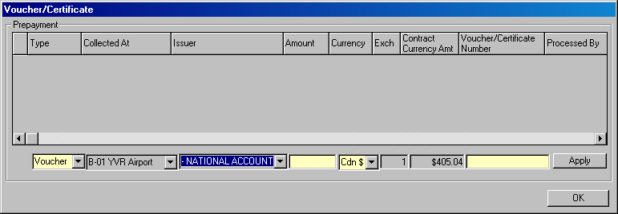

The Voucher/Certificate/PO Number will be mandatory if any of the following conditions is satisfied
- The Tour Account flag is on, Maestro Rate Override is off and CID exists (eg: zodiac and lufthansa)
- PO_Required field is checked on ACCPAC
- The Tour Account flag is on, Maestro Rate Override flag is on and CID shows S/Voucher

A reminder in red will also appear then the Voucher/Certificate/PO Number field is mandatory.

Vehicle Rate Maintenance

The rate structure in tour reservations are usually predefined and are not disclosed to the customer. Vouchers are paid in advance and usually cover all time + kilometer charges (may also include location fee, taxes, VLF and ERF depending on the voucher agreement) for a certain period of time. If the vehicle stays with the customer longer than the originally scheduled return time, then the extra rental days and surcharges (e.g. location fee and taxes etc.) if any, will be the sole responsibility of the renter. The Vehicle Rate Maintenance screen has been modified to accommodate the add-on of a different rate structure on top of the pre-defined voucher rate.

The Time Period drop down list has been expanded to include another set of time periods with an X-prefix. These new time periods are used to define a different set of rates if a tour rental is extended beyond the prearranged length of the reservation. Any extended time periods defined for the tour rate and their corresponding rate amounts will be displayed on the rental agreement and receipt. The rates for additional days should be significantly higher than the tour rate.

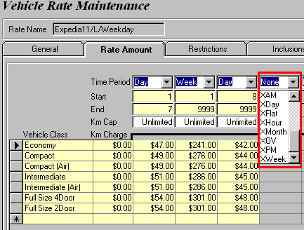

The rates for these extended time periods will also cover all inclusions selected in the tour rate’s Inclusions tab.

Possible Enhancement (not implemented currently) – suggested by Roy
Instead of assigning a Xday rate to each vehicle class individually, the “Amount Markup” field (on the General tab) can be set up so that all rate amounts for the extra time periods can be bumped up by changing only that field. If the user wants more control over the individual rate amounts, then s/he can go into the Rate Amount tab to define the rate one by one.

Intair Transit (KTMI) and Westjet (KTEI) behave slightly differently. Eg. If the package is $150 (in concept), we wanna show customers that this package includes HST. But in reality, when we bill Intair and Westjet, the $150 becomes a net package and does not include HST. So we have to bill them $150 + $18 (for HST) = $168. this will be shown on the vab submission report. Out HST GL account should have $18 too. So to solve this problem, we will just markup the tour package value.

Any tax, VLF, ERF or location fee selected in the Inclusions tab are included in the rate and will be displayed as an included item on the contract printout.

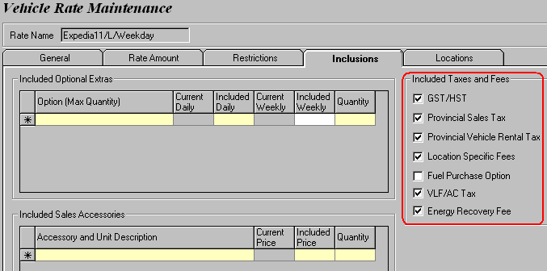

If Included_In_Rate for GPS is flagged in the Contract_Optional_Extra table, then a different GPS addendum template will be used to hide the actual price.

Only Taxes, VLF, ERF and location fee will go into their respective GL account if they are included in the rate. Others such as FPO, LDW, GPS, optional extras, coverages and sales accessories on the other hand will just go into the Time + KM GL. In the example below, the included LDW / Tour Standard is $8/day and will be counted as a part of Time + KM.

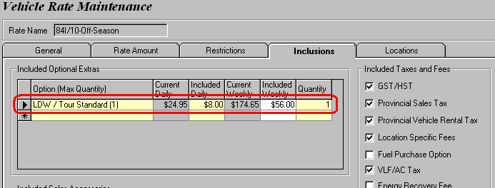

As a precaution, if the Purpose of the rate is “Tour Pkg”, then GIS will prompt the user to define additional day (XDay) rates on top of the base rate structure.

Location Maintenance

A new table called Tour_Drop_Off_Charge is added to control the drop off charges for tour contracts. The purpose of adding this table instead of sharing it with the Drop Off Location table in Location Maintenance is to better restrict and differentiate the drop off locations for tour rentals because only a limited number of locations are permitted for returning the vehicle. Therefore, if a vehicle is returned to an unauthorized location (i.e. not in the Tour_Drop_Off_Charge table), then the Default Unauthorized Charge will kick in.

Drop off charges are calculated based on the following conditions:
  - pick up location and drop off location
  - whether or not the drop off location is authorized
  - whether or not the Rate_Assigned_Date of the contract is with the Valid From and Valid To date of the drop off charge

 | Authorized DO loc in Location Maintenance (Authorized=Yes) | Unauthorized DO loc in Location Maintenance  (Authorized=No) | DO loc not added in grid in Location Maintenance
Authorized DO loc in Vehicle Rate Maintenance | Authorized Charge | Unauthorized Charge | Default Unauthorized Charge
Unauthorized DO loc in Vehicle Rate Maintenance | Unauthorized Charge | Unauthorized Charge | Default Unauthorized Charge

Certificate

Contract Open

To enter a certificate, click the Voucher/Certificate button under the Payment tab to bring up the Voucher/Certificate window.

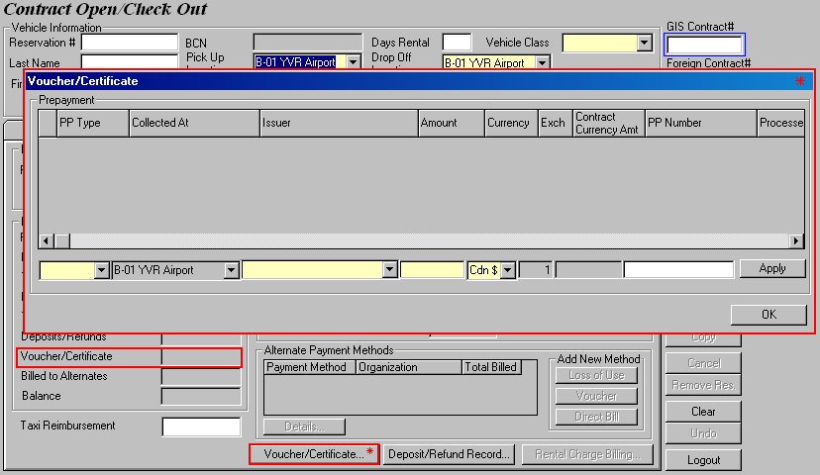

Any amount added through the Voucher/Certificate window will appear in the Voucher/Certificate field on the Payment tab. Any added rental certificates should not affect the Estimated Charges on the Comments tab since they are merely an alternate form of payment that the customer uses in paying out the rental.

Any voucher amount in the contract should not be included in the calculation for Estimated Charges on the Comments tab. The reason for this is because the voucher is pre-paid and the customer need not know about the actual voucher amount.

As per the fine print on the Air Miles Rental Certificate, certificates cannot be combined with Air Miles redemption bookings, i.e. reservations that are delivered with a a BCD number of A571600 (AIR MILES LOYALTY GRP). When Air Miles certificates are used, we can issue Air Miles reward miles.

Functions
Pre-Write: Checks that all mandatory information (except the check-out vehicle’s information) are entered before saving the contract. Voucher and certificate are optional in a contract and cannot be used as a primary payment. The primary payment GIS accepts are in the form of direct bill, credit card and cash.

Check Out (1): Checks that all mandatory information are entered before saving the contract. Voucher and certificate are optional in a contract and cannot be used as a primary payment. The primary payment GIS accepts are in the form of direct bill, credit card and cash. Prints Budget Copy.

Check Out (2): Checks that all mandatory information are entered before saving the contract. Voucher and certificate are optional in a contract and cannot be used as a primary payment. The primary payment GIS accepts are in the form of direct bill, credit card and cash. Prints Budget and Customer Copy.

Clear: Disabled once a certificate or a voucher has been added or removed.

Undo: Disabled once a certificate or a voucher has been added or removed.

Accounting
Certificates used on GIS go into the GIS Customer Deposit GL account.

Contract Printout
All the entered certificates will be printed on the contract in the Deposit section. Only the Type, Date, Amount and Location are printed.

Contract Changes During Rental

Certificates can only be viewed but no modified in Contract Changes through the Voucher/Certificate window.

Contract Check In

Certificates can only be viewed but no modified in Contract Check In through the Voucher/Certificate window.

GIS will always take certificate(s) into first priority when calculating the payment for rental charges. If the certificate alone is sufficient to cover the entire rental, then no other payment methods are required and no amount has to be paid at all. When this happens, the Balance label will be replaced with ‘Non-Refundable Balance’ and Payment Amount will display $0 to avoid confusion.

Functions
Check In: Checks that all mandatory information has been entered before the contract can be saved. Prints Budget Copy and Customer Copy. See the section below for different checkin scenarios regarding contracts with certificates and vouchers.

Print: Only enabled when the contract is closed. Prints Budget Copy.

Void: Only enabled if the checked out date occurred on the same RBR date.

Clear: Disabled once a certificate or a voucher has been added or removed. Enabled again after contract is closed.

Undo: Disabled once a certificate or a voucher has been added or removed.

Certificate Check In Scenarios
1. Primary payment method: Credit card
Certificate: Yes
Total rental charges > Certificate

GIS will always collect the full certificate amount to cover a portion of the rental charges. Any remaining rental charges will be processed on the primary credit card.

2. Primary payment method: Credit card
Certificate: Yes
Total rental charges <= Certificate

Handheld will first collect the full certificate amount to cover the entire rental amount. The Balance field under the Payment tab will have its label changed to display Non-Refundable Balance and show the unredeemed cert value. Payment Amount will be $0 since the certificate amount is sufficient. User can then proceed to check in.

Upon checkin, GIS automatically converts the Non-Refundable Balance into a manual rental charge billing item called ‘Unredeemed Prepayment’ (charge type 44 in Lookup_Table) under Rental Charge Billing.
→ Update Total Charges and Taxes field to reflect the total certificate amount
→ Non-Refundable Balance turns back to Balance and shows $0

3. Primary payment method: Credit card
Certificate: Yes
Total rental charges < Certificate < Certificate + Credit card deposit

GIS will prompt user to refund deposit upon clicking the Check In button because the certificate alone is sufficient to cover the entire rental amount. After the refund is processed, the Balance field under the Payment tab will have its label changed to display Non-Refundable Balance and show the unredeemed cert value. Payment Amount will be $0 since the certificate amount is sufficient. User can then proceed to check in. The amount allowed for refund cannot exceed the collected amount.
4. Primary payment method: Credit card
Certificate: Yes
Certificate < Total rental charges < Certificate + Credit card deposit

The outstanding balance after certificate is deducted from the total rental charges will be charged to the credit card. GIS will prompt user to collect/refund deposit until Payment Amount becomes $0.

Handheld Scenarios
1. Primary payment method: Credit card
Certificate: Yes
Total rental charges > Certificate

Handheld will first collect the full certificate amount to cover a portion of the rental charges. Any remaining rental charges will be processed on the primary credit card and the handheld will print express checkin receipt.

2. Primary payment method: Credit card
Certificate: Yes
Total rental charges <= Certificate

Handheld will use the certificate(s) to cover the entire rental charges and print express checkin receipt. Any unused certificate amount will be printed under Non Refundable Balance.

3. Primary payment method: Credit card
Certificate: Yes
Total rental charges < Certificate < Certificate + Credit card deposit

Handheld will refund the entire deposit and print express checkin receipt. Any unused certificate amount will be printed under Non Refundable Balance.

4. Primary payment method: Credit card
Certificate: Yes
Certificate < Total rental charges < Certificate + Credit card deposit

Handheld will first use the full certificate amount to cover a portion of the rental charges, then it will use the credit card deposit to cover the rest of the rental charges. Any remaining balance on the credit card deposit will be refunded and handheld will print express checkin receipt.

5. Primary payment method: Credit card
Certificate: Yes
Total rental charges > Certificate + credit card deposit

Similar to case 1, the handheld will first collect the full certificate amount to cover a portion of the rental charges, then it will use the entire credit card deposit to cover some more of the rental charges. The remaining rental charges will be processed on the primary credit card and handheld will print express checkin receipt.
6. Primary payment method: Credit card
Alternate payment method: Cash/debit card
Certificate: Yes
Certificate < Total rental charges < Certificate + cash/debit card deposit

Handheld will print a sendin slip. The reason for the sendin is because after the full certificate amount is used to cover a portion of the rental charges, the cash or debit card deposit will eventually need to be refunded and this can only be done at the counter. This applies to both Canadian and US cash.

7. Primary payment method: Cash
Certificate: Yes
Total Rental Charges > Certificate

Handheld always prints sendin slip when Renter Pre-Authorization Method is ‘Cash’.

8. Primary payment method: Direct bill
Certificate: Yes
Total Rental Charges > Certificate

Handheld will first collect the full certificate amount to cover a portion of the rental charges. Any remaining rental charges will be assigned to direct bill and the handheld will print express checkin receipt.

9. Primary payment method: Direct bill
Certificate: Yes
Total Rental Charges <= Certificate

Handheld will use the certificate(s) to cover the entire rental charges and print express checkin receipt.

10. Primary payment method: Credit card
Alternate payment method: Direct bill
Certificate: Yes
Total Rental Charges > Certificate + Direct bill assignments

Handheld always print sendin slip when a direct bill alternate payment exists. Even if the alternate billing assignments and split charges are not reset due to a rental cost recalculation, handheld will still print sendin slip (Technically there should not be a sendin if the alternate billing assignments are not reset as per the handheld business design document).

Accounting
Certificates used on GIS go into the GIS Customer Deposit GL account. Any unused portion of the rental certificate(s) is non-refundable and goes into the Time + KM GL account.

Receipt
All certificates will be printed on the receipt in the Deposit section. This time, the issuer and PP number will be printed along with the Type, Date, Amount and Location from the contract printout.

A Certificate field which records the total rental certificate amount will be added in the Amount Owing section. Any unused portion of the rental certificate(s) cannot be refunded to the customer and will be displayed on the receipt as a non-refundable balance.

Contract Adjustments

Voucher and certificates are temporarily disabled in Contract Adjustment. GIS allows adjustment items to be deducted from any unused certificate amount though the Unredeemed Prepayment charge item (charge type 44 in Lookup_Table). Whenever the Unredeemed Prepayment item is selected, the tax fields (i.e. GST/HST, PST and PVRT) will be defaulted to No and grayed out. GIS also validates the maximum amount that can be deducted from the unredeemed prepayment.

Functions
Save: Checks that all mandatory information has been entered before the contract can be saved.

Print (1): Checks that all mandatory information are entered and then saves updated contract. Prints Budget Copy.

Print (2): Checks that all mandatory information are entered and then saves updated contract. Prints Budget and Customer Copy.

Void: Only enabled if the checked out date occurred on the same RBR date.

Clear: Disabled once a certificate or a voucher has been added or removed. Enabled again after contract is closed.

Undo: Disabled once a certificate or a voucher has been added or removed.

Accounting
Certificates used on GIS go into the GIS Customer Deposit GL account. Any unused portion of the rental certificate(s) is non-refundable and goes into the Time + KM GL account.
Adjustment Scenarios
1. Primary payment method: Credit card
Credit card payment in Check In: Yes
Certificate: Yes
Certificate < Total adjustment charges

The certificate will be used to cover a potion of the adjustment charges and the rest will be charged to the credit card.

2. Primary payment method: Credit card
Credit card payment in Check In: Yes
Certificate: Yes
Certificate > Total adjustment charges

Once the certificate pays out the entire adjustment charges, any remaining unused certificate amount will be used to pay for the rental charges in checkin that were processed on credit card. Therefore GIS will prompt a refund of $(Certificate - Total adjustment charges) to the credit card.

3. Primary payment method: Credit card
Credit card payment in Check In: Yes
Certificate: Yes
Certificate > Total adjustment charges + Total rental charges (from Check In) &
Certificate > Total rental charges (from Check In)

With the certificate paying for the adjustment + rental charges and having some unused balance left, the entire credit card payment collected upon Check In will have to be refunded. The Non-Refund Balance will also display the remaining certificate amount. The updated contract can be saved once the refund is processed. Upon saving, GIS automatically converts the Non-Refund Balance into a manual rental charge billing item called ‘Unredeemed Prepayment’ (charge type 44 in Lookup_Table) in the Previous Adjustment section.
→ Update Total Charges field to reflect the total certificate amount
→ Non-Refund Balance turns back to Balance Owing and shows $0

Receipt
All certificates will be printed on the receipt in the Deposit section. This time, the issuer and PP number will be printed along with the Type, Date, Amount and Location from the contract printout.

A Certificate field which records the total rental certificate amount will be added in the Amount Owing section. Any unused portion of the rental certificate(s) cannot be refunded to the customer and will be displayed on the receipt as a non-refundable balance.

Foreign Check In

Certificates do not apply in foreign check in.

VAB Submission Report
The right hand column of the report will list all voucher amounts for contracts which are closed on the specified date range. Expedia rentals (BCD#411700) are not included in this report.

Voucher

Contract Open

Like certificates, vouchers can be added through the Voucher/Certificate window.

Any amount added through the Voucher/Certificate window will appear in the Voucher/Certificate field on the Payment tab. Any added rental certificates should not affect the Estimated Charges on the Comments tab since they are merely an alternate form of payment that the customer uses in paying out the rental.

If the reservation is a tour reservation, GIS will check that a voucher is assigned to the contract upon clicking the Pre-write or Check Out button and prompt the user to add voucher if s/he has not.
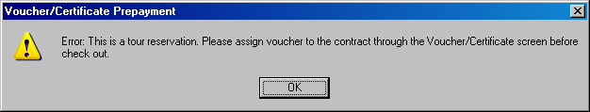

Rental Charge Billing
All voucher inclusions will not be displayed in the Rental Charge Billing. If the rental is extended beyond the original time period, then the applicable extended rate will be displayed in the grid (charge type 9 in Lookup_Table). Any coverages, optional extras, sales accessories added to the contract that are not included in the tour rate will appear in the grid and are subject to taxes and surcharges.

Accounting
All voucher amounts added in Contract Open go into the GIS Customer Deposit GL account.

Contract Printout
The rental agreement will display the length of the prepaid rental as delivered from Maestro. The structure of the tour rate is confidential and will not be revealed on the rental agreement. However, the rate name and extended rate structure (i.e. time periods with the X-prefix) will be displayed, if any. All rate inclusions selected in the Vehicle Rate Maintenance screen for the tour rate will be clearly displayed on the rental agreement. “Renter is responsible for all non-package items and applicable taxes and surcharges.” will print beneath the inclusions.

The total voucher will not (and cannot) be printed on the contract. The rate/price of all vehicle rental inclusions (e.g. VLF, ERF, location fee, optional extra etc.) will also be hidden on the rental agreement. If an additional item added to the contract is not included in the tour rate, then the associate surcharges applicable to that item will be shown on the contract for the the customer’s reference.

If the voucher is inclusive of GPS, then the GPS addendum printed will not show the unit or weekly price of the GPS.

Contract Changes During Rental

Vouchers can only be viewed but not modifed in Contract Changes through the Voucher/Certificate window.

Contract Check In

Vouchers can only be viewed but not modifed in Contract Check In through the Voucher/Certificate window.

Vouchers are always calculated based on the length of rental starting from the pick up date and time. In other words, if the renter is scheduled to pick up his vehicle on Mar 10 at 9AM and return it the same time on Mar 165, but if he picks up the vehicle on Mar 10 at 4PM, then the voucher should cover his rental until 4PM on Mar 165 as well. In normal circumstances, the same weekly rates applies for rentals ranging from 5 to 7 days. However, if the tour rate in used in the example above is a weekly rate, extending the rental by another day will trigger the additional day charge because the voucher is only prepaid for 6 days instead of 7 days, regardless of whether or not the tour rate is daily or weekly.

Rental Charges will not include voucher amount on front end for voucher, we don’t want csr to reveal the actual rental amount to tour customers. So, if the tour voucher amount is the total amount, then Rental Charges will show 0. If there are any additonal charges on top of the voucher amount, then Rental Charges will show the additional charges only.

Accounting
A voucher amount will be split accordingly to the appropriate GL account for time + km, taxes, VLF, ERF and location fee. If the rental includes optional extras or coverages, however, these revenue will be combined and recorded in the time + km GL account.

Handheld
All voucher rentals can be checked in through handheld provided that the contract does not meet the send in conditions. The handheld receipt will display the length of the prepaid rental as delivered from Maestro as well as hide the amount of the voucher and all rate inclusions.

Receipt
The rental agreement will display the length of the prepaid rental as delivered from Maestro. The structure of the tour rate is confidential and will not be revealed on the rental agreement. However, the extended rate structure (i.e. time periods with the X-prefix) will be displayed, if any. All rate inclusions selected in the Vehicle Rate Maintenance screen for the tour rate will be clearly displayed on the rental agreement.

The total voucher will not (and cannot) be printed on the contract. The price of all vehicle rental inclusions excluding VLF, ERF and location fee will also be hidden on the receipt.

If an additional item added to the contract is not included in the tour rate, then it will be displayed in the Non-package Charges section of the receipt showing its amount and all associated taxes and surcharges.

Contract Adjustments

Vouchers can only be viewed but not modifed in Contract Check In through the Voucher/Certificate window.

Foreign Check In
Vouchers do not apply in foreign check in.

VAB Submission Report
The right hand column of the report will list all certificate amounts for contracts which are closed on the specified date range.

Inclusions

Changes to the Contract_Charge_Item table
- Added ERF_Days

This column always shows the total days of rental for the ‘Vehicle Rental’ charge item regardless of whether or not the vehicle rental is inclusive of any surcharges. This is used to calculate the value for ERF_Included when the rate is inclusive.

- Added VLF_Days

This column always shows the total days of rental for the ‘Vehicle Rental’ charge item regardless of whether or not the vehicle rental is inclusive of any surcharges. This is used to calculate the value for VLF_Included when the rate is inclusive.

- Added CRF_Included column

This column indicates whether the charge item includes Concession Recovery Fee (or better known as Airport Concession Fee).

- Added VLF_Included column

This column indicates whether the charge item includes Vehicle License Fee.

- Added ERF_Included column

This column indicates whether the charge item includes Energy Recovery Fee.

All contracts that were checked out and checked in prior to the voucher implementation will have NULL values in these columns. Need to ensure that these contracts can be saved properly.

Changes to the Charge_Parameter table
- Added HST_Exempt column

- Added HST2_Exempt column

The GST_Exempt column in the Contract_Charge_Item table only provides information about whether or not GST/HST applies to the charge item. However, since HST rate can vary by optional extra (HST=12% and HST2=5%), there needs to be a way for the system to identify the correct HST rate to be applied. The solution is to add the two columns above in the Charge_Parameter table and link them to the GST_Exempt column in the Contract_Charge_Item table.

If a charge item is not exempt from GST/HST (i.e. GST_Exempt=1), then the contract will refer to the Charge_Parameter table to pick the correct HST rate.

- If HST_Exempt=1, then HST2_Exempt must be 0
The contract will apply a 5% HST to the charge item
- If HST_Exempt=0, then HST2_Exempt=1
The contract will apply a 12% HST instead

Formula for deriving the net rental amount from a gross amount that includes net rental, taxes (i.e. HST) and all surcharges (i.e. location fee/CRF, VLF, ERF) and other extras (e.g. optional extra, coverage, sales accessory etc.)

NetAmt=(GrossAmt–(VLF+ERF+OtherExtra)*(1+CRF)*(1+HST))/(1+CRF)*(1+HST)

